**SOFTWARE DEVELOPMENT LIFE CYCLE (SDLC) WATERFALL METHOD**

**REQUIREMENTS (AND ANALYSIS)**

Requirements include:

Resources

* Team members which we assigned each a specific work to do
* One Computer System for one member
* Cards to understand the cards game

Information

* Crazy 5 cards is a game that is simple, it is played with a full deck of 52 cars excluding the jokers. There can be two players, but there can also be four players to play the game.

The players have to have five deck of cards each taken from the 52 deck of cards. Players have to sit opposite to each other so that they cannot see each other’s cards. In the card game a player have to have an ace or a ten and four cards to win, an ace or a ten, two cards of the same king and another two cards of the same kind to win, three cards of the same kind and two cards of the same kind to win. To obtain the cards to win they have to pick one card from the deck of cards and make a decision on which card to throw away from the players cards (5 + 1 = 6 cards), a player is supposed to have five (5) cards only. The other player can then choose which cad they would like to pick from the deck of cards or from the played cards and make a decision on which one to throw.

The players continue playing until one player wins.

Functionality

* The card game functions fine. Its function is to entertain people and it is a fun game. It relaxes your mind

Performance

* It performs fine and it is very quick, but you have to work and think in order to win.

What needs to be analysed

* **Development**: the program will be used in any computer system including cell phones for those who are interested to play the game
* **Utilization:** by connecting then in a way that one depends on the other
* **Mission Scenario:** by making it attractive and complex
* **Performance:** player and a deck of cads
* **Effectiveness:** very effective

**DESIGN**

1. **Technologies:**
   1. The data structures we used were as follows:
      1. Array list – This was to store all the deck of cards, player hand cards and the deck that player throw the card away.
      2. Interface representation- We made a presentation on how the game is played and the rules.
      3. Algorithmic details:

UML

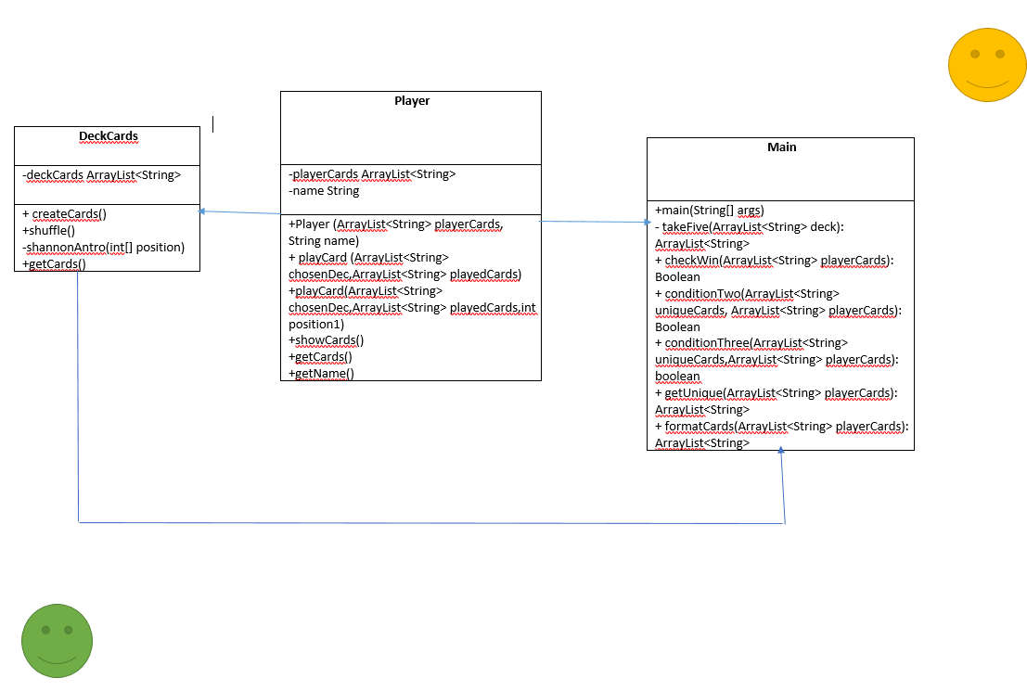

**Time and budget**

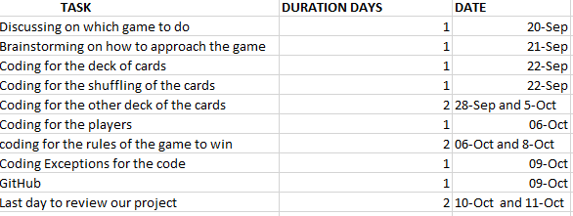

**IMPLEMENTATION**

* Algorithm to play the card game:
* A player1 and player2 must have five cards each
* Player1 picks one card from the deck
* Choose from the six cards that player1 now have and decide on which one you want to throw
* Player2 can now decide on which deck of cards to choose from, player2 can choose from the deck or the played cards.
* Player2 then chooses which card to throw away too
* The game continues until on player wins and say, ‘I WON!’
* Source code writing
* Code is correct and neat
* Compilation
* The code compiles fine
* Testing and debugging
* We tested and it is working